MCj04280710000[1]Ethics

Ethics are the rules of personal behavior accepted by society. Ethics are also known as a “code of conduct”. We are confronted with choices every day. Most often we make good choices, but sometimes we falter. Our personal values determine the strength of our ethics. When an individual is unethical, even if they don’t get caught, they lose integrity and self-respect. An ethical person is a good citizen at home, at school or work, and in the community. Ethics are about the individual. Those who practice good ethics are respected, well liked, admired, and trustworthy. Doing what is right will always make you a stronger person and, most often, make your school or workplace a better place.

Listen to the Video **“Anti-bullying anthem”** and then make a list below of the brothers’ comments in the song about being bullied.

List 2 actions you would consider to be unethical at school:

1. ______________________________
2. ______________________________

List 2 actions you would consider to be unethical at work:

1. ______________________________
2. ______________________________

List 2 actions you would consider to be unethical at home:

1. ______________________________
2. ______________________________

___________________________________ ___________________________________

___________________________________ ___________________________________

___________________________________ ___________________________________

___________________________________ ___________________________________

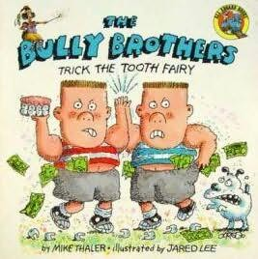___________________________________ ___________________________________

After watching **“Fishing With Sam”,** write a paragraph about the unethical behaviors of the one penguin. Why were his actions unethical?

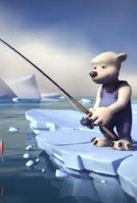

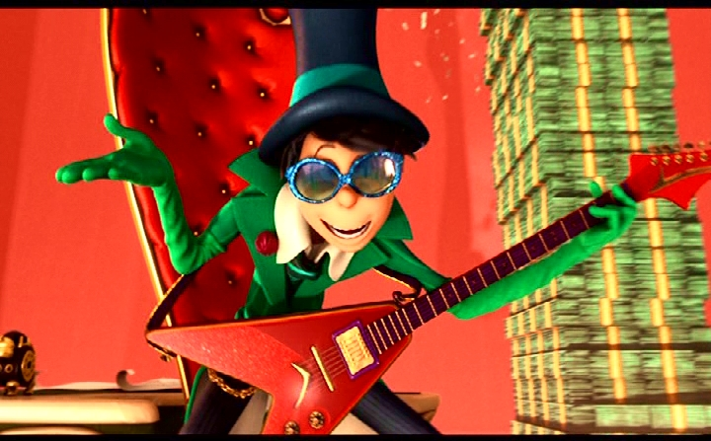Watch “**How Bad Can I Be -The Lorax”,** and then write a paragraph about consequences of unethical behavior in business.